**ECEN 4303 Digital Integrated Circuit**

**Chapter 4: The Four-Terminal MOS Transistor**

* Transistor Regions of Operation
  + Body-reference  
    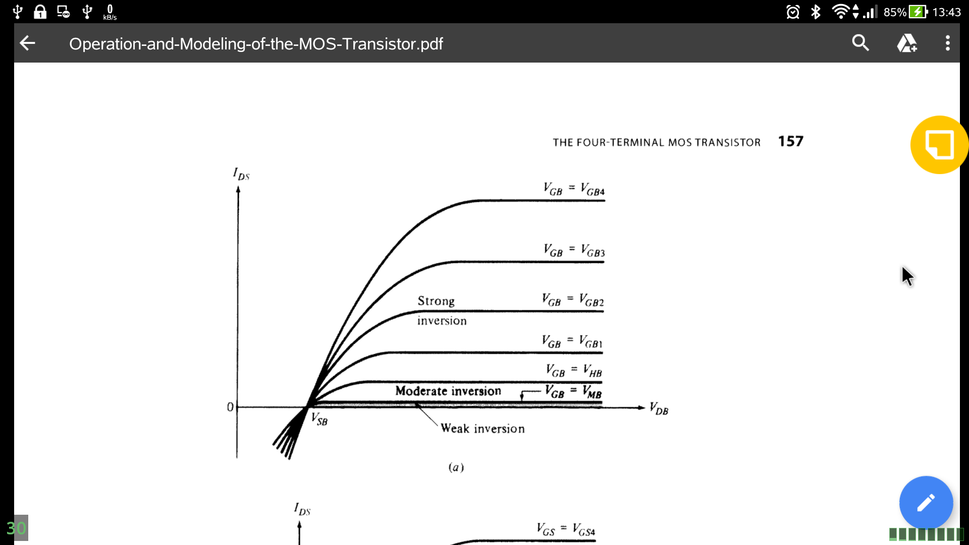
  + Source-reference  
    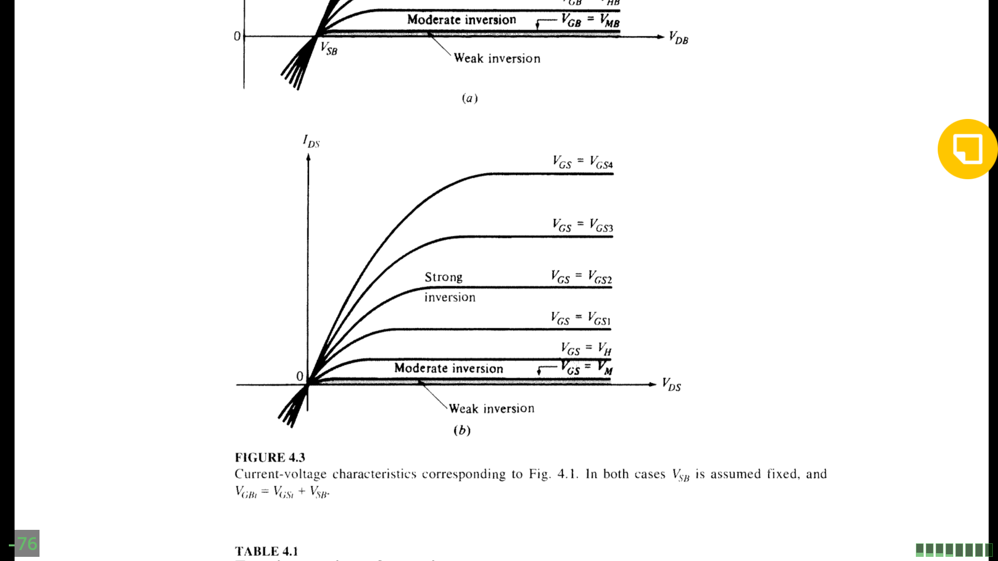
* Complete All-Region Model
  + Current Equation
 $I(x)=I_{drift}(x)+I_{diffusion}(x)$ $I_{drift}(x)=μW\left(-Q_{1}'\right)\frac{dψ_{s}}{dx}$ $I_{diffusion}(x)=μWϕ_{t}\frac{dQ_{1}'}{dx}$

+ Body-Referenced Simplified All-Region Models
 $I_{DS1}=\frac{W}{L}μC_{ox}'\left(V_{GB}-V_{FB}-ψ_{sm}-γ\sqrt{ψ_{sm}}\right)\left(ψ_{sL}-ψ_{s0}\right)$ $I_{DS2}=\frac{W}{L}μC_{ox}'α_{m}ϕ_{t}\left(ψ_{sL}-ψ_{s0}\right)$ $α=α_{m}=1+\frac{γ}{2\sqrt{ψ_{sm}}}$

+ Source-Referenced Simplified All-Region Models
$I_{DS1}=\frac{W}{L}μC_{ox}'\left[\left(V_{GB}-V_{FB}-ψ_{s0}-γ\sqrt{ψ_{s0}}\right)\left(ψ_{sL}-ψ_{s0}\right)-\frac{α}{2}{\left(ψ_{sL}-ψ_{s0}\right)}^{2}\right]$ $I_{DS2}=\frac{W}{L}μC_{ox}'αϕ_{t}\left(ψ_{sL}-ψ_{s0}\right)$ $α=α_{1}=1+\frac{γ}{2\sqrt{ψ_{s0}}}$

* Strong Inversion
  + Complete Strong-Inversion Model
    - Non-saturation
 $I_{DSN}=\frac{W}{L}μC_{ox}'\left\{\left(V_{GB}-V_{FB}-ϕ_{0}\right)\left(V_{DB}-V_{SB}\right)-\frac{1}{2}\left(V_{DB}^{2}-V_{SB}^{2}\right)-\frac{2}{3}γ\left[{\left(ϕ_{0}+V_{DB}\right)}^{3/2}-{\left(ϕ_{0}+V_{SB}\right)}^{3/2}\right]\right\}$

   - Derivation Directly in Strong Inversion
    - Forward Saturation
      * Pinchoff voltage is equal to drain to body voltage $V_{P}={\left(-\frac{γ}{2}+\sqrt{\frac{γ^{2}}{4}+V_{GB}-V_{FB}}\right)}^{2}-ϕ_{0}$ $I_{DS}'=I_{DSN}|_{V_{DB}=V_{P}}$ $I_{DS}=\{_{I_{DS}', V_{DB}>V_{P}}^{I_{DSN}, V_{DB}≤V_{P}}$
    - Reverse Saturation
 $V_{DB}>V_{SB}$ $I_{DS}''=I_{DSN}|_{V_{SB}=V_{P}}$

+ Body-Referenced Simplified Strong-Inversion Model $I_{DSN}=\frac{W}{L}μC_{ox}'\left(V_{GB}-V_{FB}-ϕ_{0}-\frac{V_{SB}+V_{DB}}{2}-γ\sqrt{ϕ_{0}+\frac{V_{SB}+V_{DB}}{2}}\right)\left(V_{DB}-V_{SB}\right)$
  + Source-Referenced Simplified Strong-Inversion Model $I_{DSN}=\frac{W}{L}μC_{ox}'\left[\left(V_{GB}-V_{SB}-V_{FB}-ϕ_{0}-γ\sqrt{ϕ_{0}+V_{SB}}\right)\left(V_{DB}-V_{SB}\right)-\frac{α}{2}{\left(V_{DB}-V_{SB}\right)}^{2}\right]$ 
    - Derivation directly in strong inversion $V_{DS}'=\frac{V_{GS}-V_{T}}{α}$ $I_{DS}=\{_{\frac{W}{L}μC_{ox}'\frac{{\left(V_{GS}-V_{T}\right)}^{2}}{2α}, V_{DS}>V_{DS}'}^{\frac{W}{L}μC_{ox}\left[\left(V_{GS}-V_{T}\right)V_{DS}-\frac{α}{2}V_{DS}^{2}\right] V_{DS}≤V_{DS}'}$